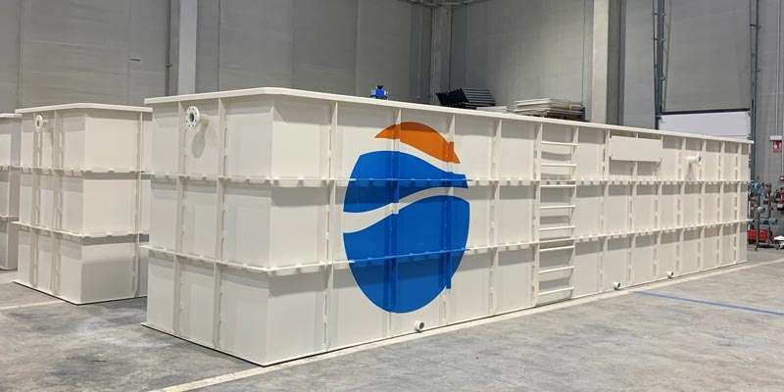

Membrane biological reactors, also known as MBR systems, are a wastewater treatment technology that combines the biodegradation of microorganisms with membrane filtration to separate solids and liquids.

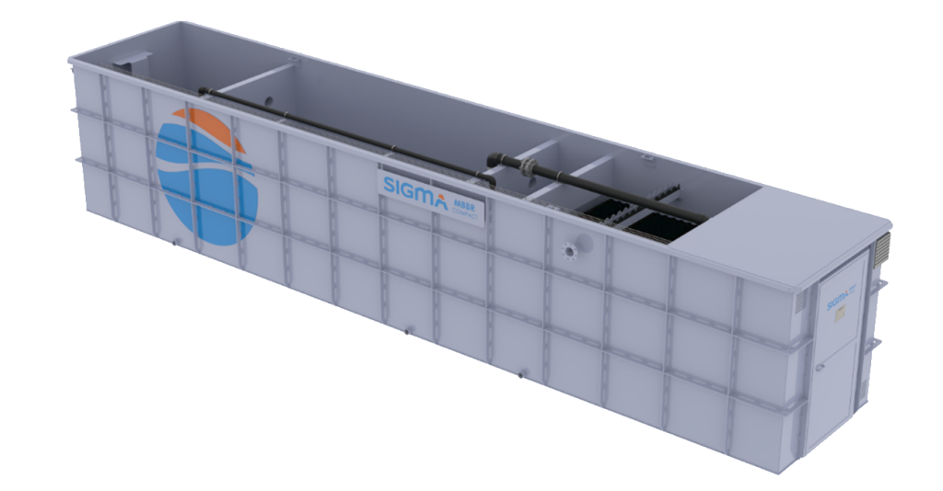

MBR systems include ultrafiltration or microfiltration membranes to separate contaminants present in the treated water. MBR systems are a compact and easy to operate technology, offering high performance for contaminant separation.

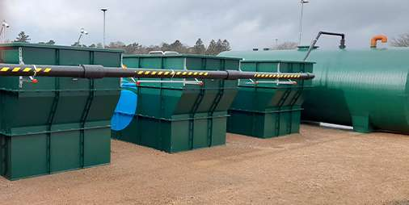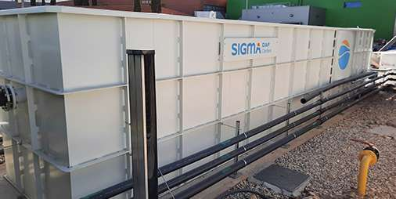

MBBR reactors, or biofilm moving bed reactors, are another technology widely used in wastewater treatment. MBBR reactors use a moving bed of support material, such as plastic or ceramic, to grow microorganisms that biodegrade contaminants in the treated water. MBBR reactors are also easy to operate and provide high pollutant separation efficiency. The following table shows the general operating conditions. The pollutant removal efficiency is optimal and the treated water is of consistent quality. The pollutant removal efficiency is very high and the treated water has a constant quality.

| **PARAMETER** | **ENTRANCE** | **EXIT** | **PERFORMANCE** |
| --- | --- | --- | --- |
| COD (mg/L) | <600 | <90 | 85% |
| BOD (mg/L) | <300 | <30 | 90% |
| TSS (mg/L) | <300 | <40 | 87% |
| TSK (mg/L) | <40 | <16 | 60% |

**Comparison of SIGMA MBR and MBBR systems**

|  | **COMPACT SMBR** | **COMPACT SMBBR** |
| --- | --- | --- |
| **DISTINCTIVE TECHNOLOGY** | Advanced Ultrafiltration membranes. | Carriers for biomass growth support |
| **BIOMASS CONCENTRATION** | 6 000 - 12 000 mg/L MLSS | 4 000 - 8 000 MLSS |
| **ELEMENTS** | Kubota Ultrafiltration membranes. Microbubble diffusers. Anoxic - aerobic chamber. | Two aerobic chambers. Specific biomass *carriers* in each chamber. Microbubble diffusers. |
| **CONCENTRATION OF POLLUTANTS IN THE DISCHARGE** | DQO <40 ppm; DBO5 <10 ppm; SST <2 ppm; NTK <10 ppm; *E. coli* 90 – 100% eliminación; Nematodos 90 – 100% eliminación; *Legionella spp.* 90 – 100% eliminación; Virus 60 – 90% eliminación; Aceites y grasas <50 ppm. | DQO <90 ppm; DBO5 <30 ppm; SST <40ppm; NTK <16 ppm. |
| **HYDRAULIC CAPACITY** | 50 - 150 m3/day. | 250 - 650 m3/day. |
| **APPLICATIONS** | Industrial and municipal waters, military camps, mining and humanitarian missions, hotels and resorts, hospitals, shopping centers, universities, fairgrounds, etc. | Industrial and municipal waters, military camps, mining and humanitarian missions, hotels and resorts, hospitals, shopping malls, universities, fairgrounds, etc. **When space requirements are very limited and maximum simplicity of operation is demanded**. |
| **MAIN ADVANTAGES** | Compact, modular, Plug&Play, high performance due to high MLSS, constant effluent quality, minimal excess sludge generation, high loading volumes, high resistance to toxic and oxidizing agents, simple operation, PLC control. | Reduced space requirements, no purging or recirculation, elimination of *bulking* problems, withstands peak loads and flow variations, simplicity of operation and control. |

**Similarities and important differences between an MBR system and an MBBR reactor**

Both technologies have several points in common, among which the following stand out:

* Both technologies use biological processes to treat wastewater, which means that they use microorganisms to biodegrade pollutants.
* Both MBR systems and MBBR reactors are highly effective in removing contaminants and can produce a high quality effluent.
* These machines have a small footprint compared to other water treatment technologies, so they can be easily installed in locations where there is not a large free area to locate the wastewater treatment plant.
* Both MBR systems and MBBR reactors can be operated autonomously and automated, reducing the need for manpower.

On the other hand, they are also two technologies with differentiated characteristics, among which the following stand out:

* MBR systems use ultrafiltration or microfiltration membranes to separate solids and liquids, while MBBR reactors use a moving bed of support material to grow microorganisms.
* MBR systems can remove smaller particles than MBBR reactors, which means they are more effective in removing specific contaminants, such as viruses or bacteria.
* MBR systems require higher power consumption for operation. This is mainly due to the need to maintain membrane pressure.
* Another factor that makes MBR systems more expensive to operate and maintain is that the membranes require regular maintenance to ensure their performance.
* MBBR reactors may be less effective in high load applications, while MBR systems are suitable for high load applications.

**Factors to consider in the selection between an MBR system and an MBBR reactor**

There is a wide variety of factors that influence the design of a wastewater treatment plant and the selection of the technologies that will be part of it. That is why it is important to analyze the specific characteristics of each case, as well as the needs and objectives set by the client.

In the design of a water treatment plant we may be faced with the need to decide between an MBR system or an MBBR reactor. Although the choice of one or the other technology depends on the specific needs of the project and there is no formula that can be applied in a generalized way, there are a series of conditions that are usually fulfilled in most cases:

* Desired quality of treated water: MBR systems produce a higher quality treated water due to their ability to remove smaller particles. The treated water can be reused in production processes and in other applications such as washing, irrigation, sanitation, etc.
* Wastewater composition: Wastewater composition refers to what types of contaminants are to be treated and how much of them are present in the wastewater effluent. MBR systems offer greater versatility in the variety of contaminants they can treat. MBBR reactors may offer better performance in wastewater that is not highly complex and requires simple operations, such as COD or BOD reduction.
* Wastewater volume: MBBR reactors have a higher hydraulic capacity and can treat a greater amount of cubic meters per day.
* Installation and operating costs: Design, construction, operation and maintenance costs are important factors in the choice of a wastewater treatment system. An MBBR reactor generally has higher design and construction costs, but has lower operation and maintenance costs. An MBR system has higher operation and maintenance costs due to the presence of membranes, which require higher energy consumption to maintain the required pressure and higher maintenance investment due to periodic cleaning and replacement.
* Environmental conditions: Local environmental conditions, such as temperature, humidity and the presence of chemicals, can also influence the choice of system.